**Google’s Colaboratory Setup Instructions**

1. Go to this Google Drive link:

https://drive.google.com/drive/folders/18wvqAelz-7lpZtK6P6ekEQot-GotOR_3?usp=sharing

1. Sign into your Google Drive or set one up.
2. Click on the Day 0 - Python Intro folder name and select Add To My Drive (You’ll only be able to run these files if you have your own copy saved.)

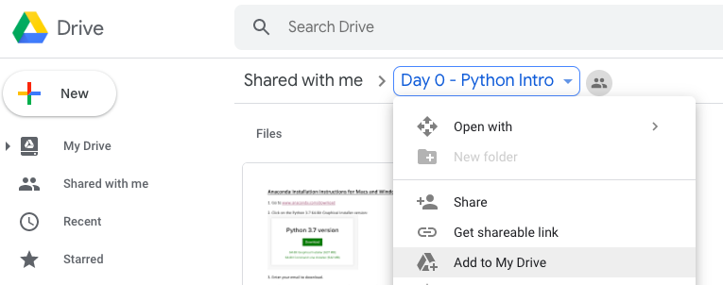

1. Navigate to the Day 0 folder that you just saved in your My Drive.
2. To open the Python Intro.ipynb file, you can right click and open with the Colaboratory app. You may need to “Connect More Apps” and search for Colaboratory if you don’t have it yet.

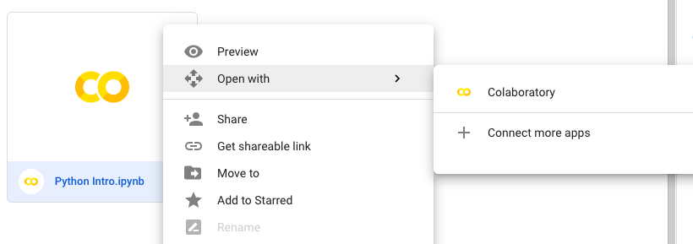

1. If everything goes according to plan, you should now be able to click on the play button to run the first line of code.

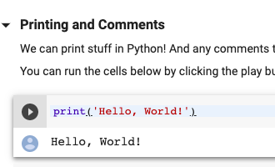

1. You can work through this file at your own pace before the class starts if you’d like. We’ll also dedicate Sunday’s class and Sunday evening’s homework to it if you don’t have time beforehand.